Day 4
1. Create an Angular application with title 'Find your blood donors'.
Create a form with one textbox with id as 'textbox' and 'Find' button.
If we enter a blood group and click the Find button the donor blood groups should be displayed.The result should be created with id as 'result'.
If we enter something other than the blood groups, it should display 'Enter a valid blood group'.

Blood Groups Blood Donors

O- universal blood group
O+ O+,A+,B+,AB+
A+ A+,AB+
A- A+,A-,AB+,AB-
B+ B+,AB+
B- B+,B-,AB+,AB-
AB+ AB+
AB- AB+,AB-
Expected Screens:
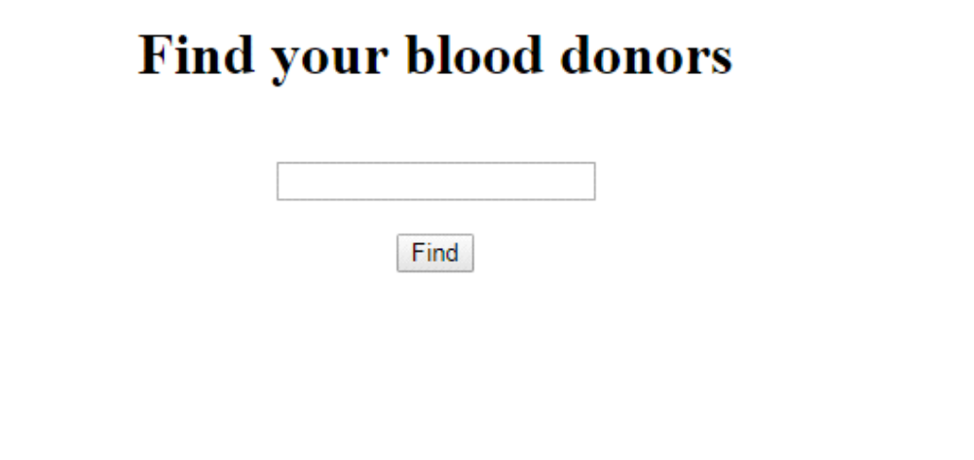
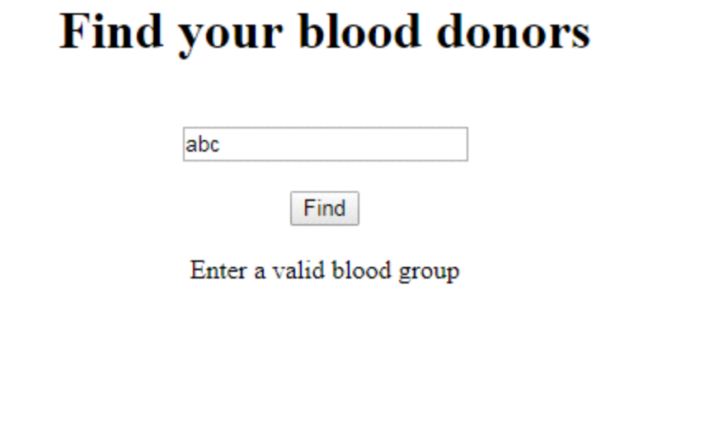
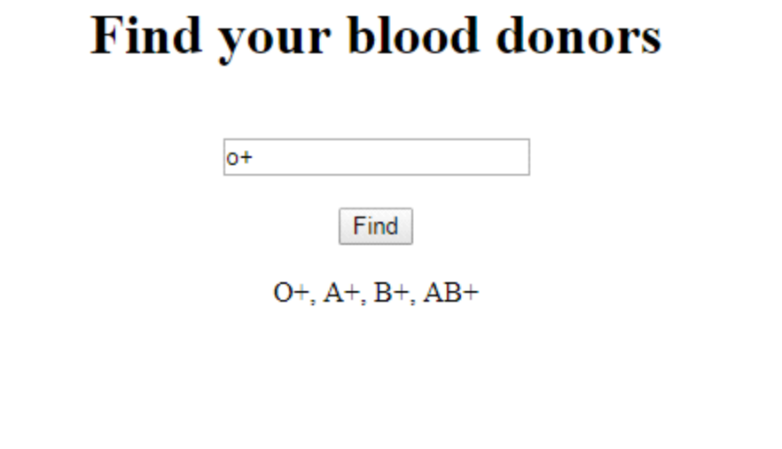
.HTML:
<!--The content below is only a placeholder and can be replaced.-->
<div style="text-align:center">
<h1> {{ title }} </h1>
<input type="text" id= "textbox" #txt> <br> <br>
<button type="submit" (click)='find(txt.value)'> Find</button> <br><br>
<div *ngIf="show">
{{ ans}}
</div>
</div>
........................
.TS:
import { Component } from '@angular/core';

@Component({
selector: 'app-root',
templateUrl: './app.component.html',
styleUrls: ['./app.component.css']
})
export class AppComponent {
title = 'Find your blood donors';
ans:any;
show:boolean;
find(value){
if(value=="O-"){
this.ans="universal blood group";
this.show=true;
}
else if(value=="O+"){
this.ans="O+,A+,B+,AB+";
this.show=true;
}
else if(value=="A+"){
this.ans="A+,AB+";
this.show=true;
}
else if(value=="A-"){
this.ans=" A+,A-,AB+,AB-";
this.show=true;
}
else if(value=="B+"){
this.ans="B+,AB+";
this.show=true;
}
else if(value=="B-"){
this.ans="B+,B-,AB+,AB-";
this.show=true;
}
else if(value=="AB+"){
this.ans="AB+";
this.show=true;
}
else if(value=="AB-"){
this.ans="AB+,AB-";
this.show=true;
}
else {
this.ans="Enter a valid blood group";
this.show=true;
}
}
}

2. Create an Angular application with title 'Welcome to Employee Details!'.Create another component as employees.Create a routerlink as 'Get'.if you click the link, it should navigate to employees component.
write the code to create a form with 3 textboxes
1.FirstName with id as 'textbox1'
2.Phone No with id as 'textbox2'
3.Email with id as 'textbox3'
4.Create a 'submit' button.
If you enter the details and click submit, an alert should get displayed as 'Employee Added Successfully'.
Expected Screens:
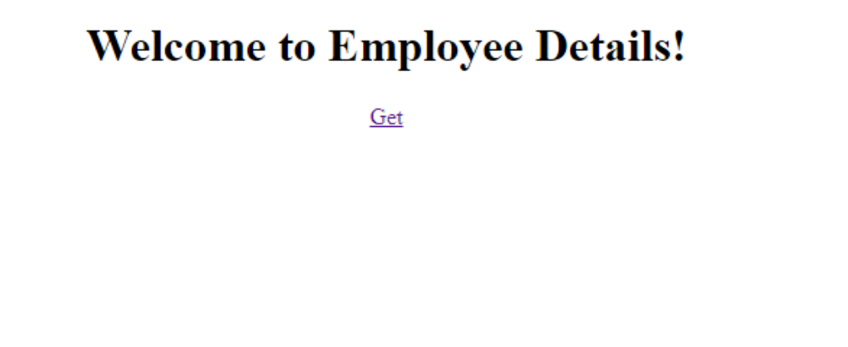
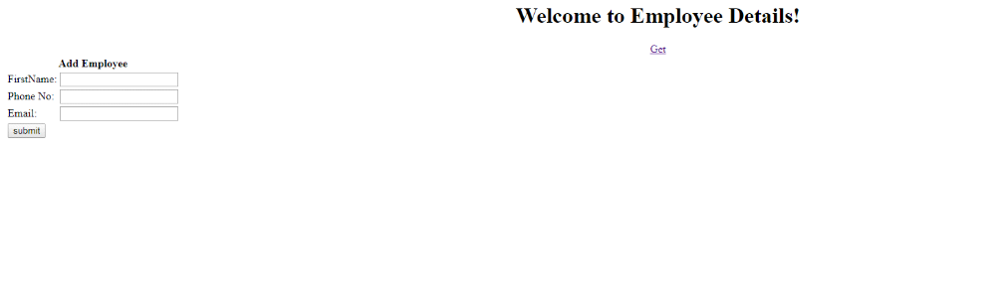
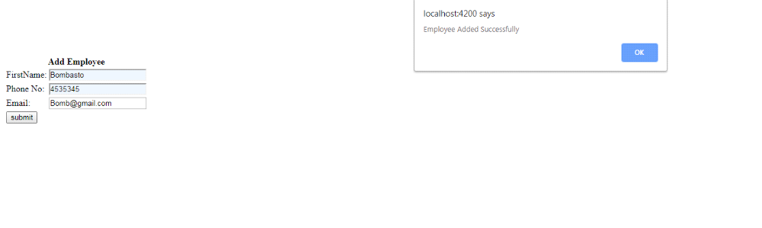
app.component.html
<!--The content below is only a placeholder and can be replaced.-->
<div style="text-align:center">
<h1>
Welcome to {{ title }}!
</h1>
<a [routerLink]="['/employees']"> Get </a>
</div>
<div class="outlet-outlet">
<router-outlet> </router-outlet>
</div>

……………….
app.component.ts
import { Component } from '@angular/core';

@Component({
selector: 'app-root',
templateUrl: './app.component.html',
styleUrls: ['./app.component.css']
})
export class AppComponent {
title = 'Employee Details';
}

……………..
app.routing module.ts
import { NgModule } from '@angular/core';
import { Routes, RouterModule } from '@angular/router';
import {EmployeesComponent} from './employees/employees.component';
const routes: Routes = [
{
path: 'employees',
component:EmployeesComponent
}
];

@NgModule({
imports: [RouterModule.forRoot(routes)],
exports: [RouterModule]
})
export class AppRoutingModule { }

…………….
employees.component.html
<div style="text-align: center">
<h5> Add Employee</h5>
<form name ="Regform">
FirstName<input type="text" id="textbox1" #txtbox1> <br>
Phone No <input type="text" id="textbox2" #txtbox2> <br>
Email <input type="text" id="textbox3" #txtbox3> <br>
<button btnCheckbox value="button" id="button" (click) ="validate(txtbox1.value)">Submit</button>
</form>
</div>
…………………….
employee.component.ts
import { Component, OnInit } from '@angular/core';

@Component({
selector: 'app-employees',
templateUrl: './employees.component.html',
styleUrls: ['./employees.component.css']
})
export class EmployeesComponent implements OnInit {

constructor() { }

ngOnInit() {
}
validate(value)
{
alert("Employee Added Successfully");
}
}

3. Create an Angular application with title 'Welcome to Employee Details!'.Create another component as employee-list.Create a routerlink as 'Get'.if you click the link, it should navigate to employee-list component.
write the code to create a form with 3 textboxes
1.FirstName with id as 'textbox1'
2.Phone No with id as 'textbox2'
3.Email with id as 'textbox3'
4.Create a 'submit' button.
If you enter the details and click submit, the data should get added in the table below as shown in the expected screens.
Expected Screens:
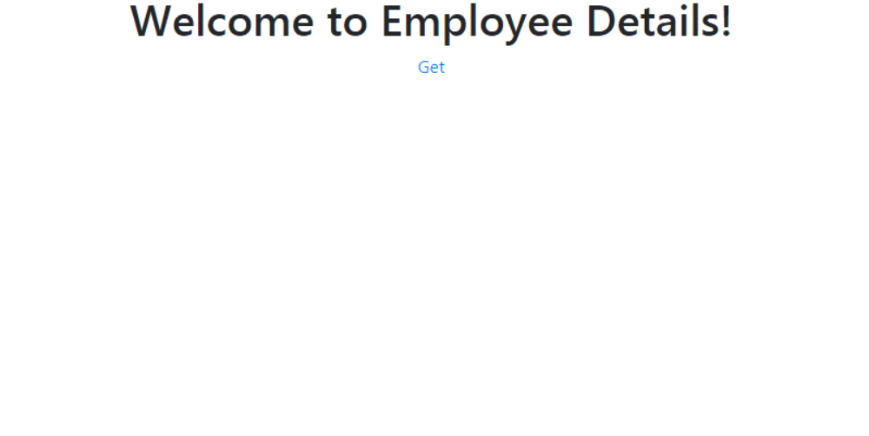
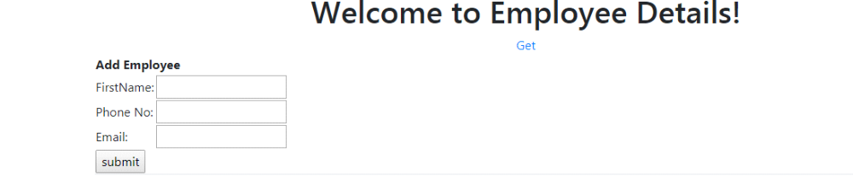
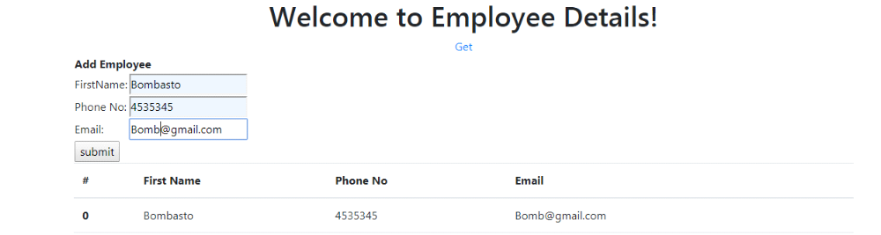
4. Create an Angular application with title 'Welcome to Employee Details!'.Create another component as employee-delete.Create a routerlink as 'Get'.if you click the link, it should navigate to employee-delete component.
write the code to create a form with 3 textboxes
1.FirstName with id as 'textbox1'
2.Phone No with id as 'textbox2'
3.Email with id as 'textbox3'
4.Create a 'submit' button.
If you enter the details and click submit, the data should get added in the table below as shown in the expected screens.Create a 'Delete' button. If you click the delete button, the particular data must be deleted.
Expected Screens:
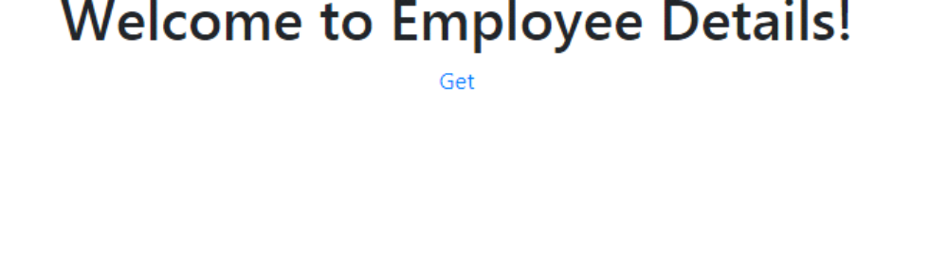
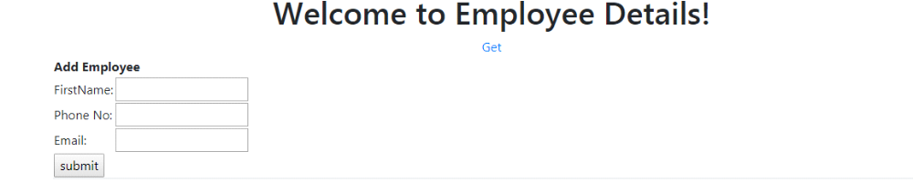
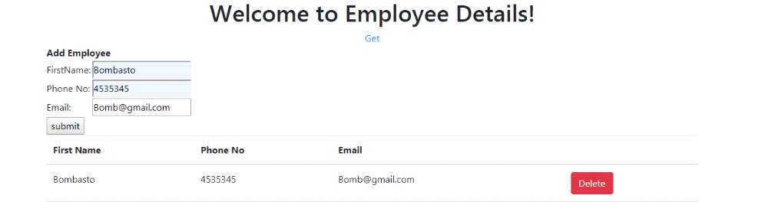

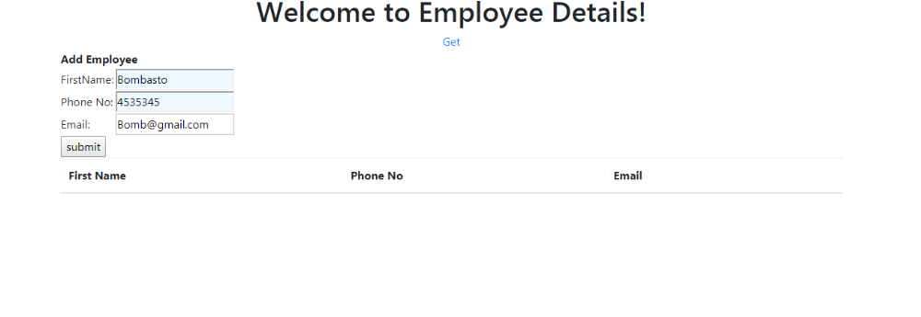
5. Create an angular application with title as 'lmsQ5'in h1 tag.Create a router link with id as 'router1'.when user clicks on a the router link it should display 2 textboxes such as name and age with id as 'name' and 'age' respectively with a submit button with id as 'button'. When user clicks on a submit button it should display a message as 'You submitted successfully'. Refer the screenshots.
Expected Screens:
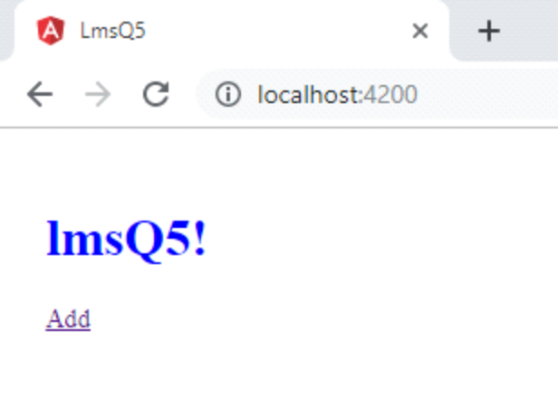
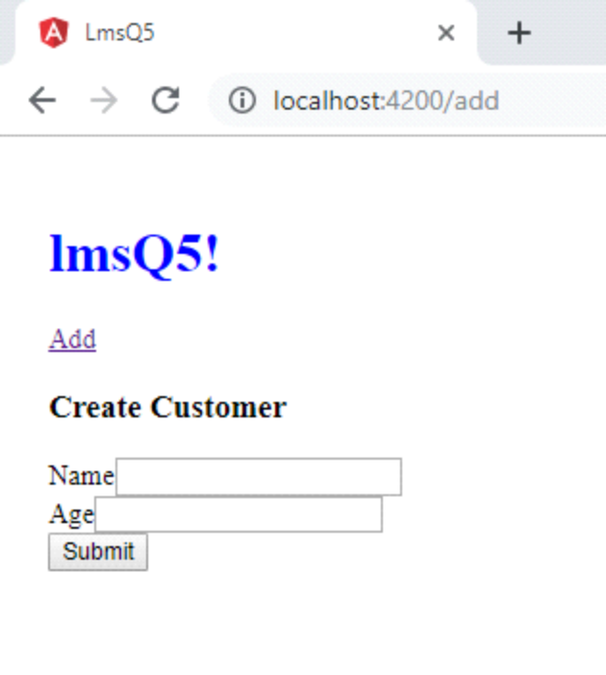
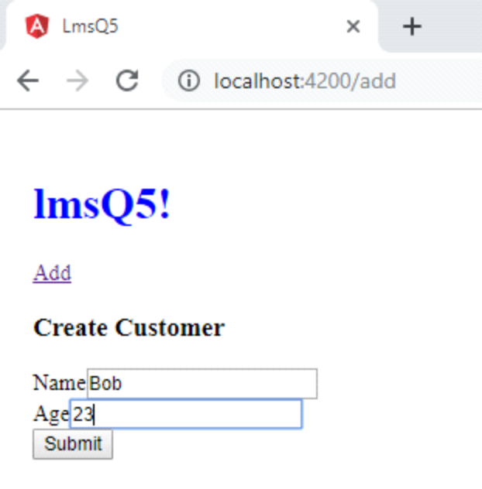
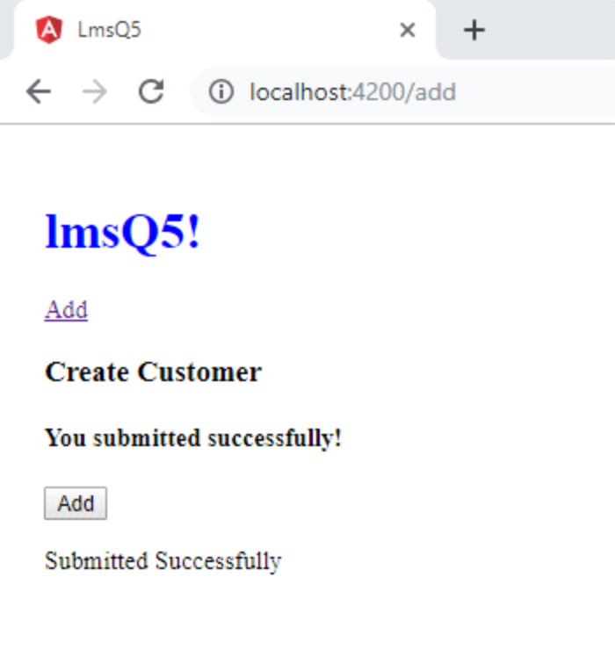
6. Create an angular application with title as 'lmsQ6'in h1 tag.Create a two router link with id as 'router1' and 'router' respectively with the link name as 'Customers' and 'Add'. when user clicks on a Add link it should display 2 textboxes such as name and age with id as 'name' and 'age' respectively with a submit button with id as 'button'. When user clicks on a submit button it should display a message as 'You submitted successfully'. When user Clicks on the 'Customers' link it should display the list of customers registered along with a button named as 'Delete All'. When user clicks on this button,all the data should get deleted.Refer the screenshots.
Expected Screens:
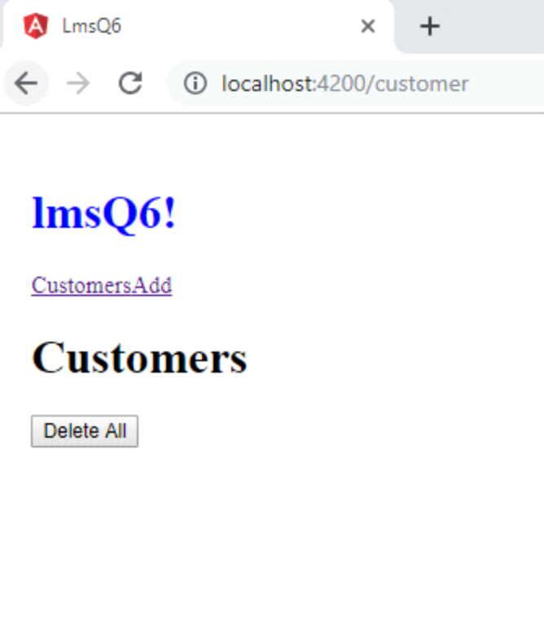
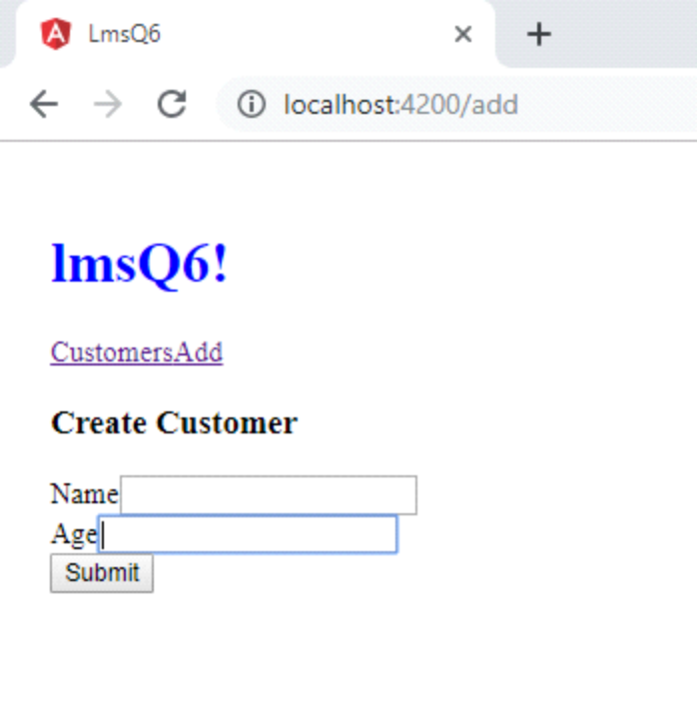
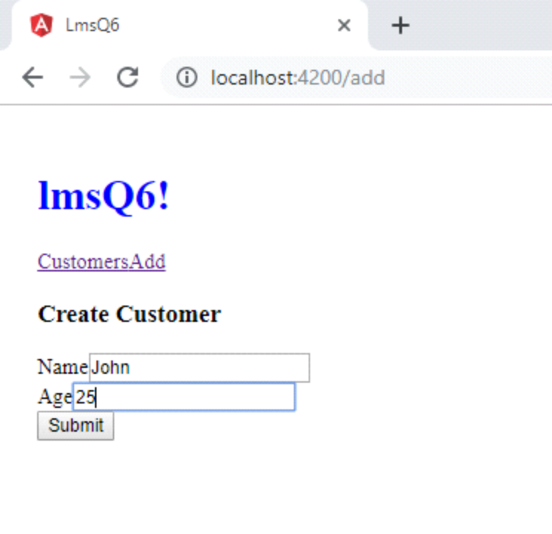
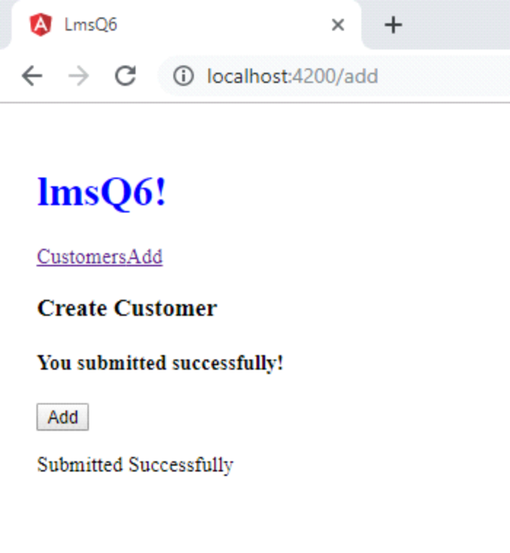
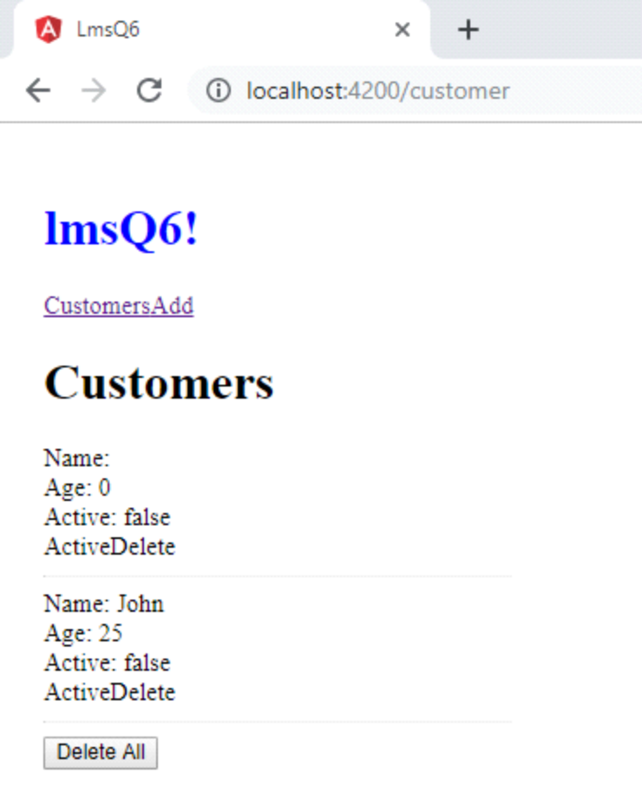
7. Create an angular application with title as 'lmsQ7'in h1 tag
Create a three router link with id as 'router1' ,'router' and 'router2' respectively with the link name as 'Customers','Add'and 'Search'
when user clicks on a Add link it should display 2 textboxes such as name and age with id as 'name' and 'age' respectively with a submit button with id as 'button'.
When user clicks on a submit button it should display a message as 'You submitted successfully'. When user Clicks on the 'Customers' link it should display the list of customers.
When user clicks on the 'search' it should display 1 textbox nameed as 'Age' with id as 'age'. When user enters the registered age it should display the name of the customers in that age.Refer the screenshots.
Expected Screens:
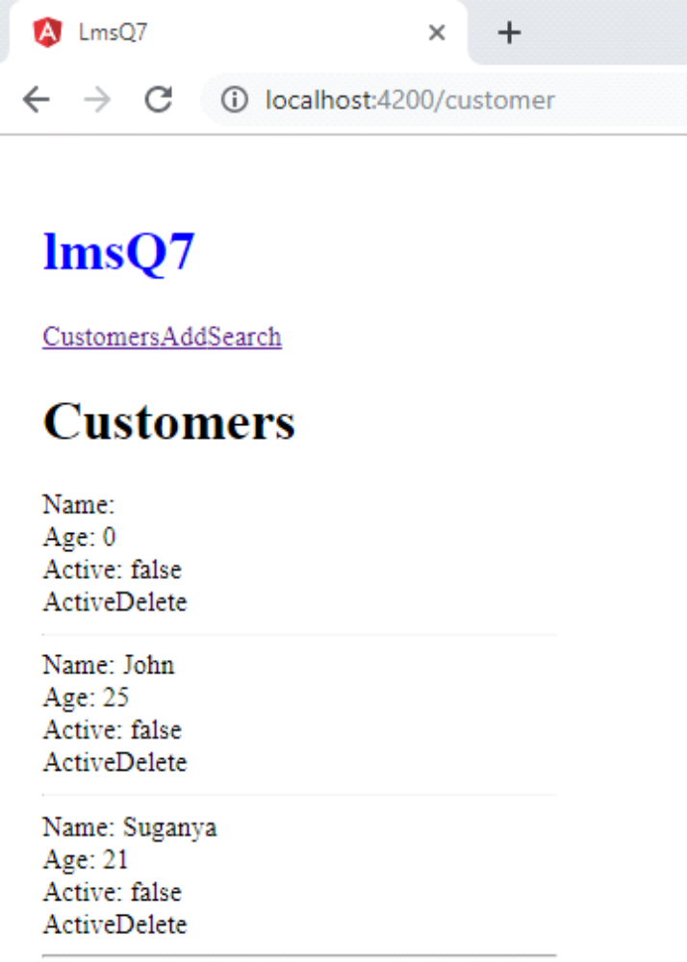
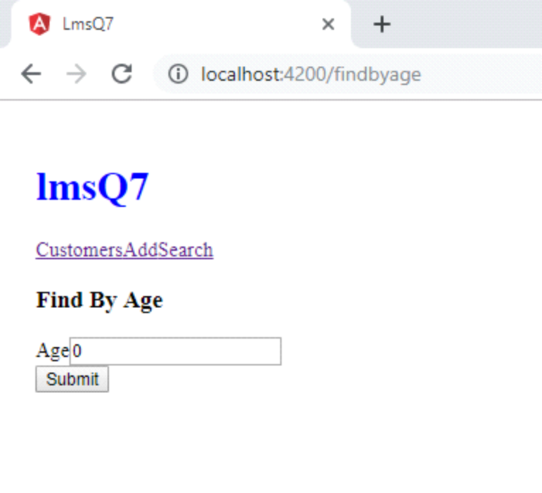
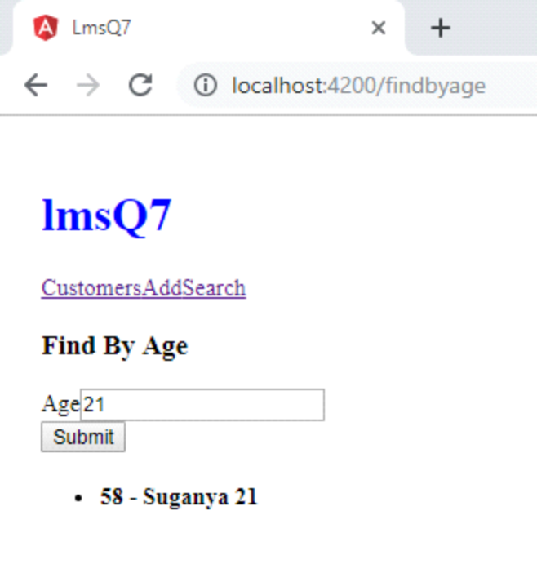
8. Create an Angular application with the title as "lmsQ9" in h1 format.Create two Routerlink
1.Link2 as add with id router.If we click add link it should directed to add page
Write the code to do the following
1.clicking the add link directed to add page that has a form contains 3 textboxes and a button
i)Firstname field with id as firstName
ii)Lastname field with id as lastName
iii)Email field with id as emailId
iv)Submit Button with id as button
After filling the details in the fields,if we Click that button we should get the text as "You submitted successfully!"(use id as result)
Expected Screens:
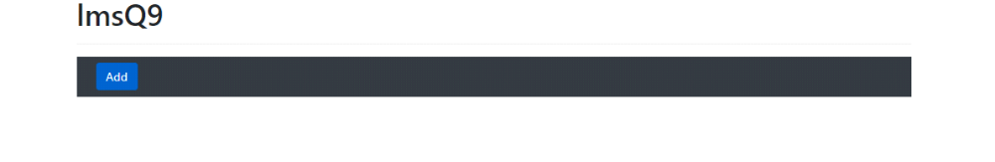
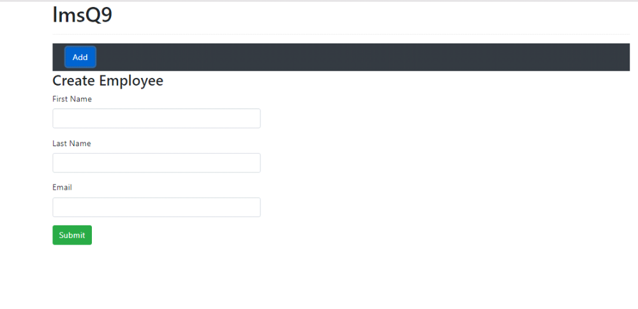
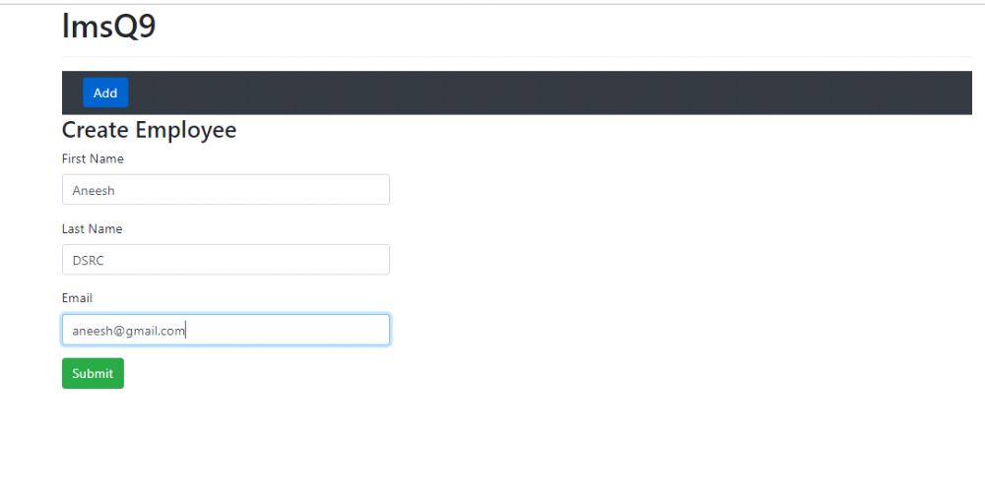
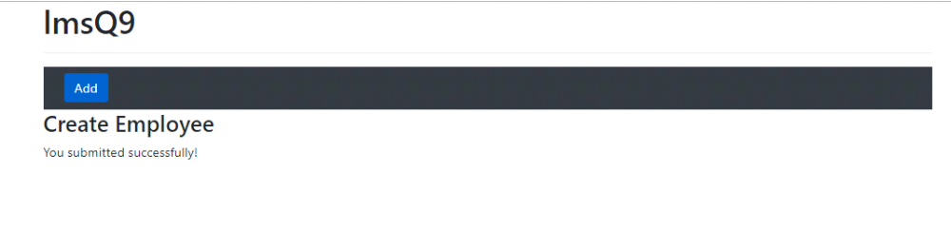
9. Create an Angular application with the title as "lmsQ10" in h1 format.Create two Routerlink
1.Link1 as employees with id router1.If we click employees link it should directed to employees page.
2.Link2 as add with id router.If we click add link it should directed to add page
Write the code to do the following
1.clicking the add link directed to add page that has a form contains 3 textboxes and a button
i)Firstname field with id as firstName
ii)Lastname field with id as lastName
iii)Email field with id as emailId
iv)Submit Button with id as button
After filling the details in the fields,if we Click that button we should get the text as "You submitted successfully!"(use id as result)
2.Clicking the employees link directed to employees page that should display the list of employees list(Refer screenshot)
Expected Screens:
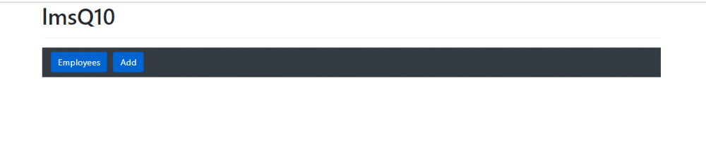
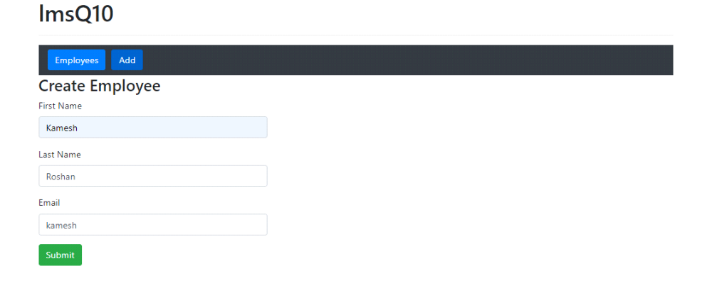
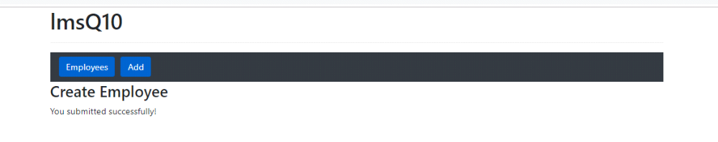

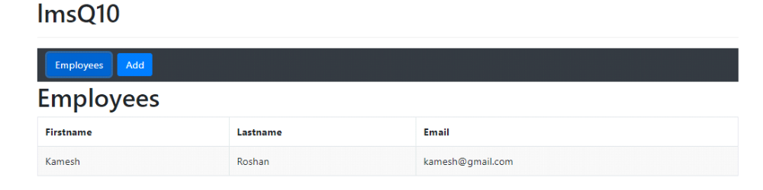
10. Create an Angular application with the title as "lmsQ8" in h1 format.Create two Routerlink
1.Link1 as employees with id router1.If we click employees link it should directed to employees page.
2.Link2 as add with id router.If we click add link it should directed to add page
Write the code to do the following
1.clicking the add link directed to add page that has a form contains 4 textboxes and a button
i)id field with id as id
ii)Firstname field with id as firstName
iii)Lastname field with id as lastName
iv)Email field with id as emailId
v)Submit Button with id as button
After filling the details in the fields,if we Click that button we should get the text as "You submitted successfully!"(use id as result)
2.Clicking the employees link directed to employees page that should display the list of employees list we saved through add page with 2 Buttons Delete and edit
i)Delete Button with id as delete
ii)Edit button with id as edit(Refer Screenshot)
3.Clicking the edit Button should direct it to the edit page with the details of particular employee filled up in the correct fields.The fields should be editable in this page.
The edited values should be updated in the employees list page
4.Clicking the Delete Button should delete the particular employee details from the list.(Refer the Screenshots)

Expected Screens:
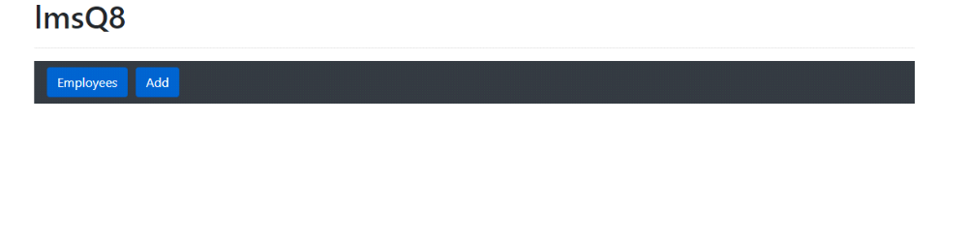
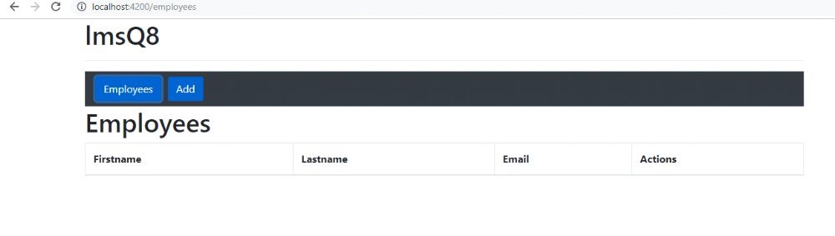
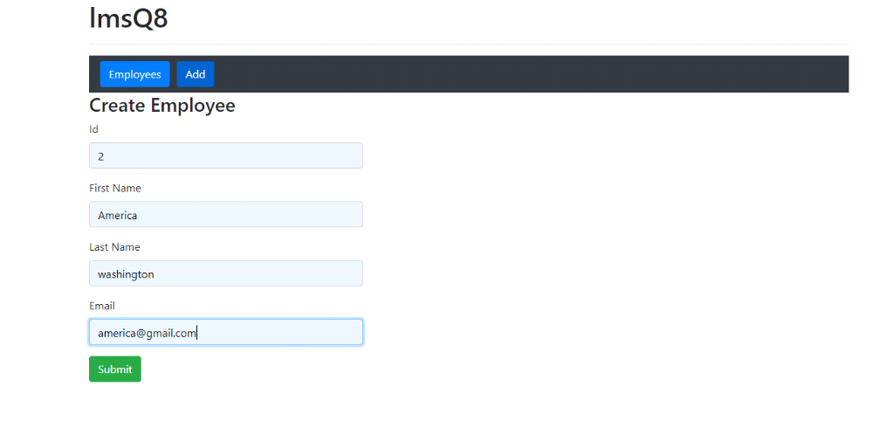

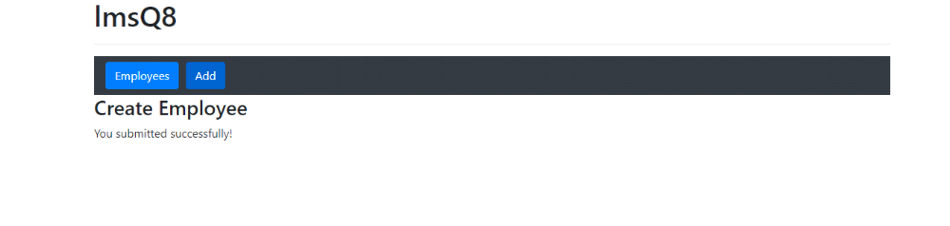
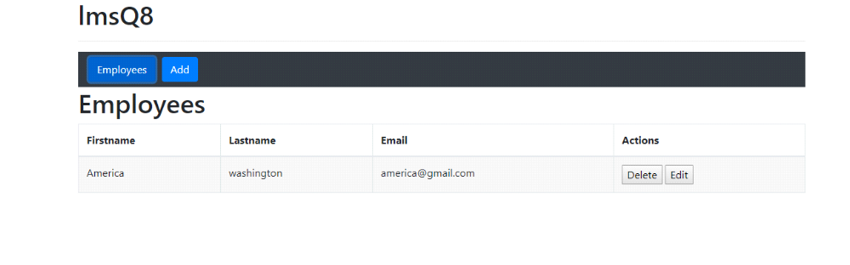
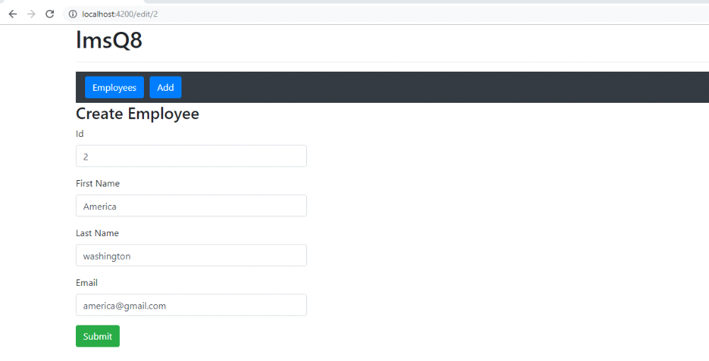
11. Create an Angular application with title 'Welcome to IP Validation!'.
Create a textbox with id as 'textbox'.
Create a button with id as 'button'.
When a valid IP address is given, then result should be displayed as 'true'.Else 'false'.Use id as 'result' for result.Refer Expected Screens.
Expected Screens:
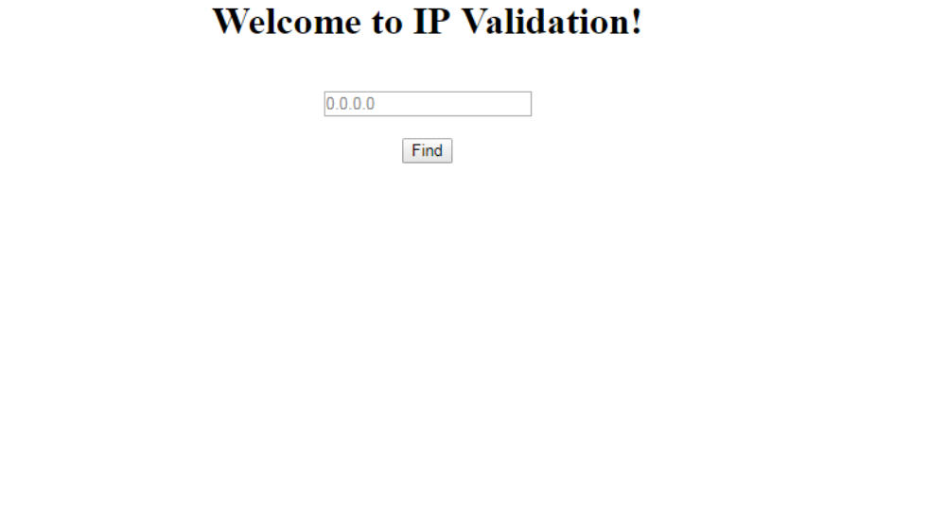
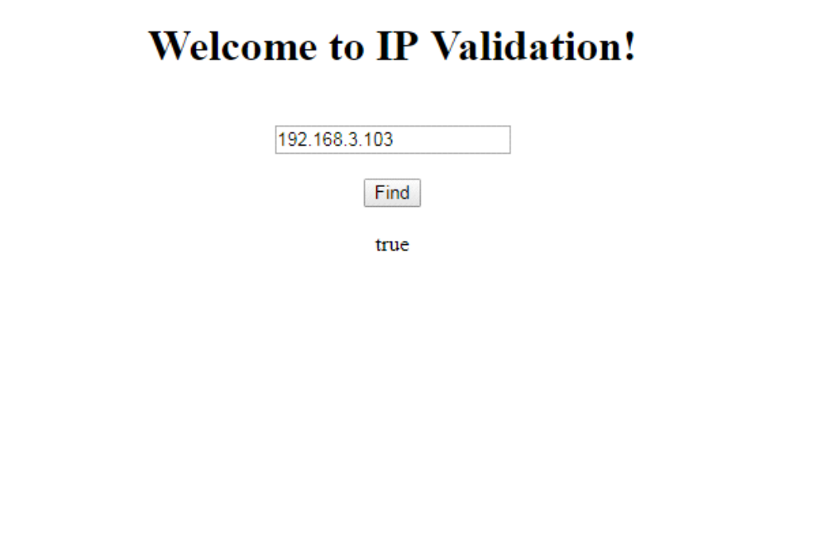
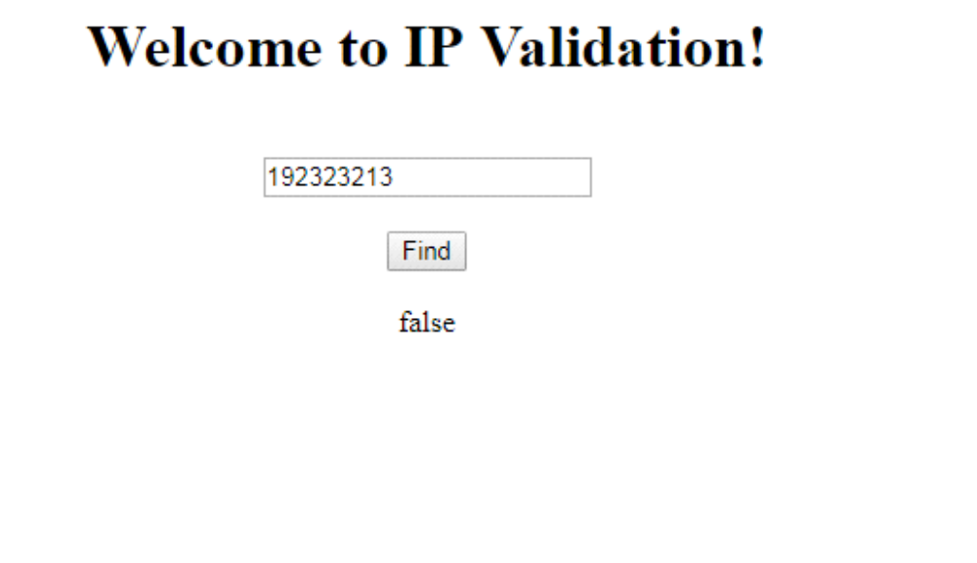
12. Create an Angular application with title 'Welcome to Date Pipe!'.Create a textbox in date format with id as 'textbox'.Create a 'Toggle Format' button.
When we click the textbox , the calender should display .
When we click the Toggle Format button, the result should be displayed as shown in Screen2.Create result with id as 'result'.
Expected Screens:
